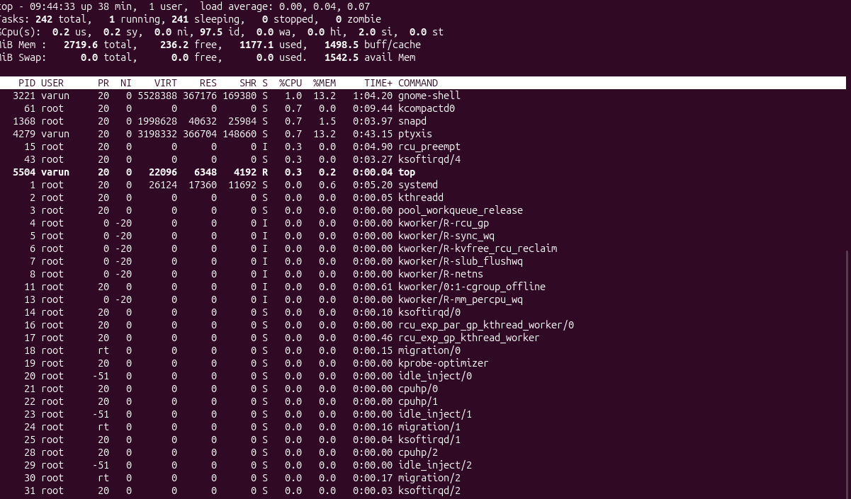

COMMAND USED HERE :- PS -EF
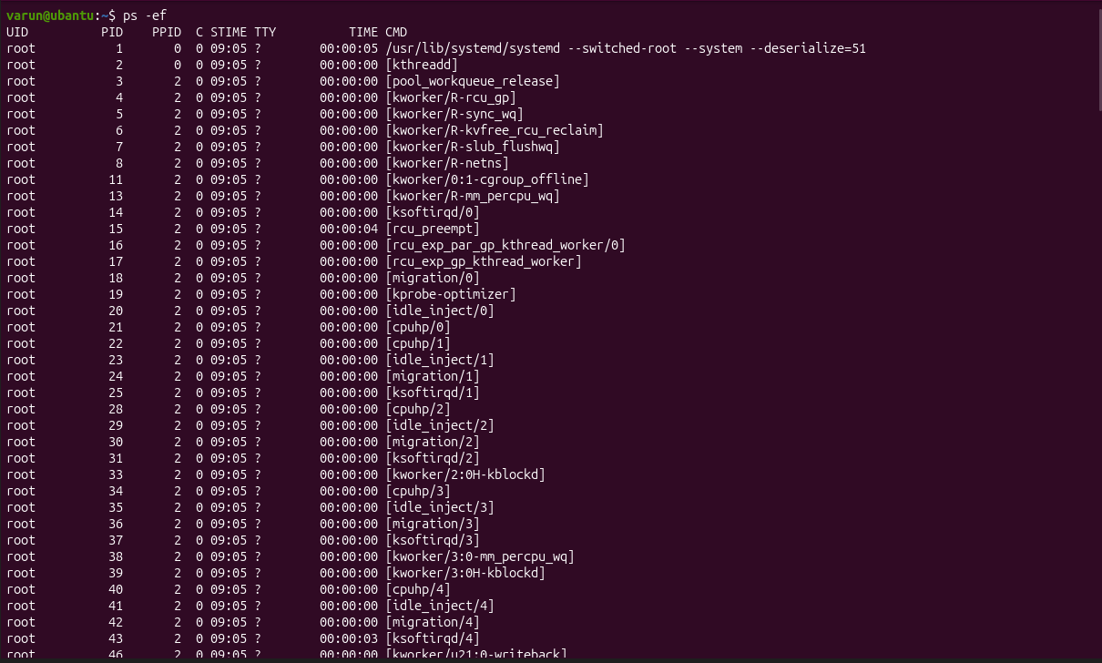

COMMAND USED : PS -EF | GREP NGINX
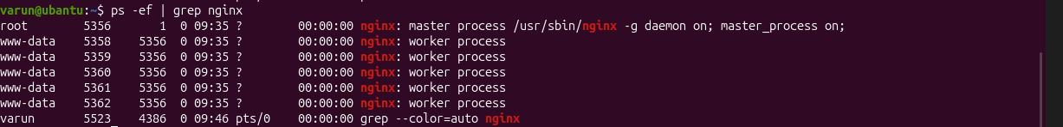

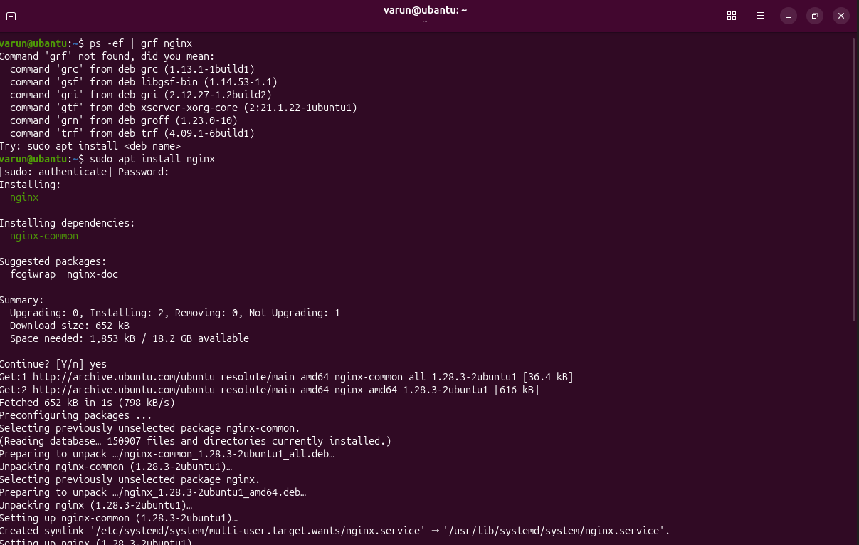

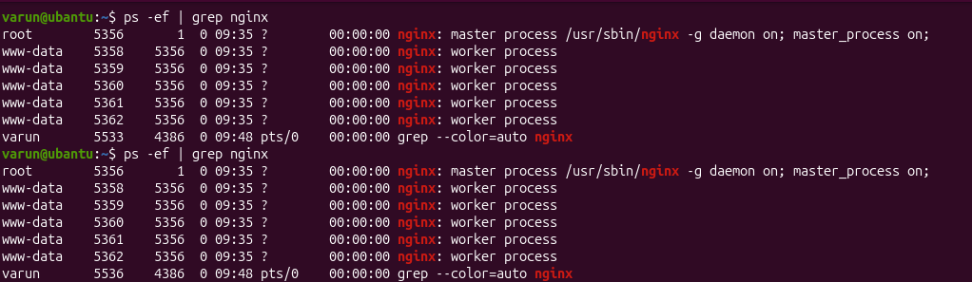

COMMANDS USED : TAR CVF TECHIE.TAR TECHIE_HORIZON / TAR XVF TECHIE.TAR TECHIE_HORIZON

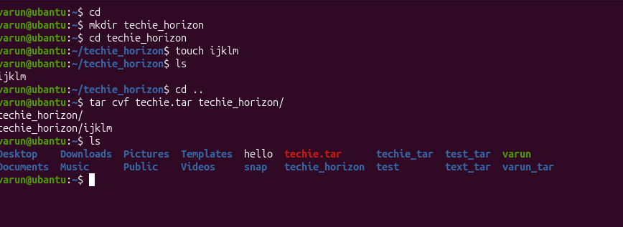

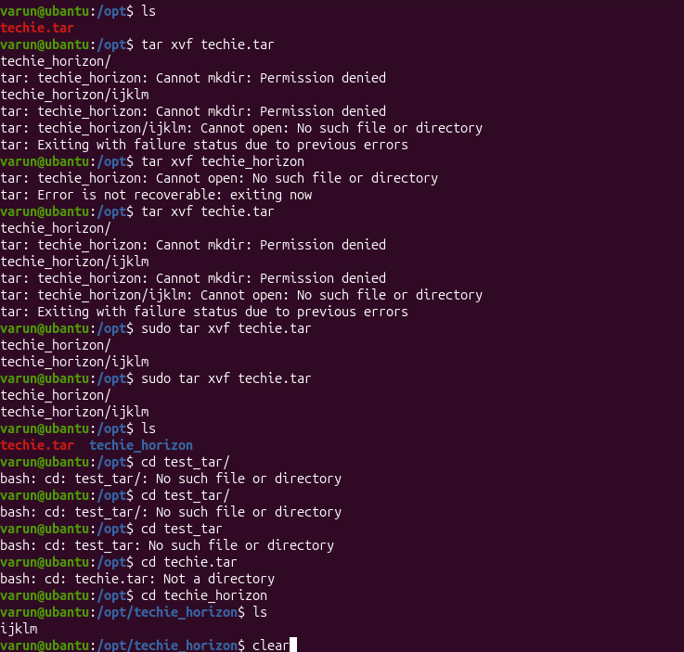
COMMANDS USED HERE: ID /UNAME AND CAT /ETC/PASSWD
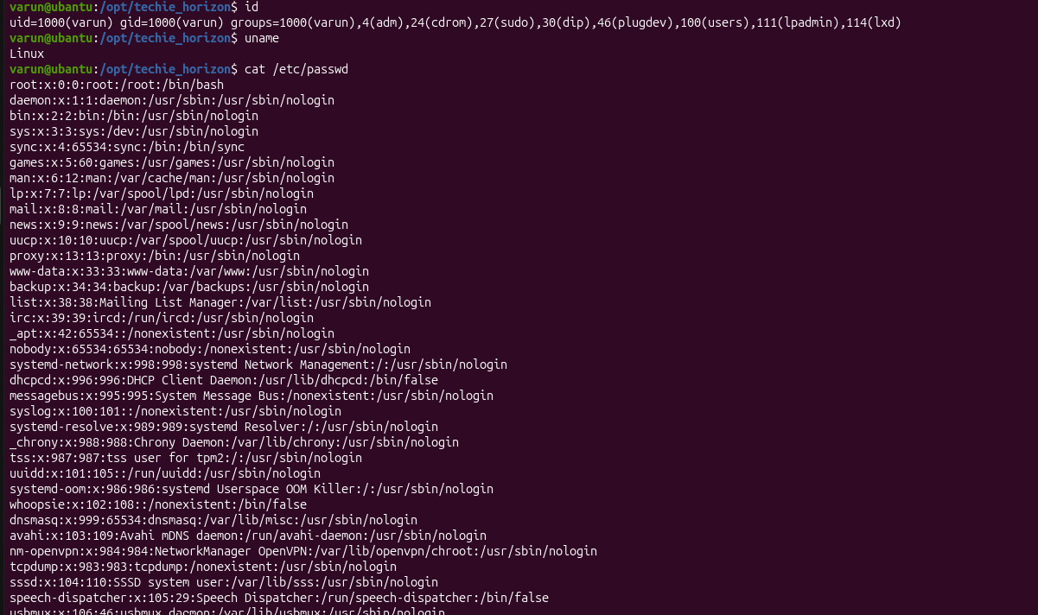
COMMAND USED HERE:CD /ETC IN NEXT LINE LS

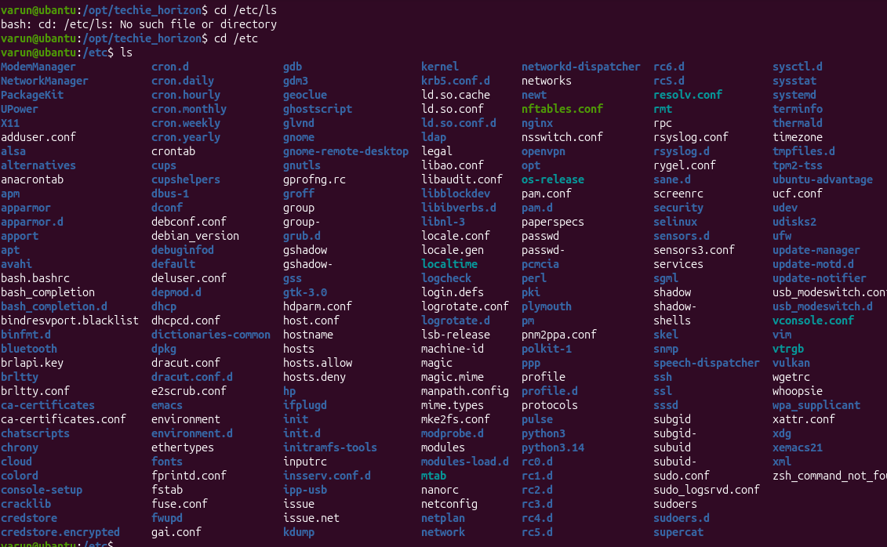

COMMAND USED HERE : DF -H
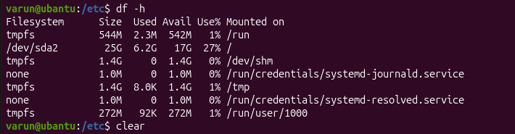

COMMAND USED HERE: DU -SK *
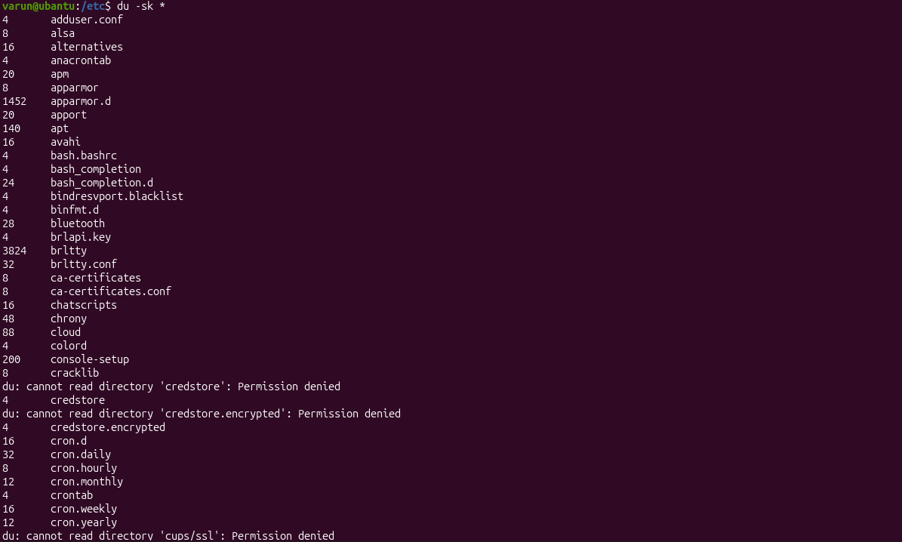

COMMAND USED HERE: FREE -M

COMMAND USED HERE: 